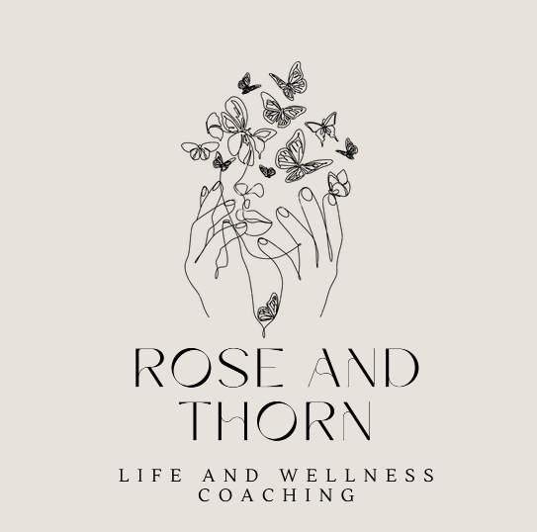
Anxiety Thought Reframing Worksheet
Rose and Thorn – Life and Wellness Coaching
www.roseandthorn.biz

Anxious Thought:
___________________________________________________________________________________________________________________________________

Evidence Supporting the Thought:
___________________________________________________________________________________________________________________________________

Evidence Against the Thought:
___________________________________________________________________________________________________________________________________

Balanced / Reframed Thought:
___________________________________________________________________________________________________________________________________

What To Do During a Panic Attack
Rose and Thorn – Life and Wellness Coaching
www.roseandthorn.biz

1. Slow breathing (inhale 4 seconds, exhale 6 seconds).
___________________________________________________________________________________________________________________________________

2. Ground yourself: name 5 things you see, 4 you feel, 3 you hear.

3. Remind yourself: panic is uncomfortable but not dangerous.

4. Stay where you are if possible and allow the anxiety to pass.

5. Avoid escaping immediately, which can reinforce the fear cycle.

Exposure Ladder (ERP)
Rose and Thorn – Life and Wellness Coaching
www.roseandthorn.biz

List feared situations from least to most anxiety provoking.
_________________________________________________________________
_________________________________________________________________
_________________________________________________________________
_________________________________________________________________
_________________________________________________________________
_________________________________________________________________
_________________________________________________________________

Situation / Trigger | Anxiety Level (0–10)
_________________________________________________________________
_________________________________________________________________
_________________________________________________________________
_________________________________________________________________
_________________________________________________________________
_________________________________________________________________
Work your way up the anxiety provoking situations while finding a way to allow the anxious thoughts (see Panic Attack worksheet)
Rumination & Overthinking Tracker
Rose and Thorn – Life and Wellness Coaching
www.roseandthorn.biz

Situation / Trigger:
___________________________________________________________________________________________________________________________________
___________________________________________________________________________________________________________________________________

Worry or Repetitive Thought:
___________________________________________________________________________________________________________________________________
___________________________________________________________________________________________________________________________________

Is this something I can control? YES / NO
____________________________________________

One small action I can take:
___________________________________________________________________________________________________________________________________
___________________________________________________________________________________________________________________________________

Weekly Life Reset Planner
Rose and Thorn – Life and Wellness Coaching
www.roseandthorn.biz
Top Priorities This Week:
____________________________________________
____________________________________________
____________________________________________
____________________________________________
____________________________________________
Appointments / Important Dates:
____________________________________________
____________________________________________
____________________________________________
Meals to Plan:
____________________________________________
____________________________________________
____________________________________________
____________________________________________
____________________________________________
Self‑Care / Personal Time:
____________________________________________
____________________________________________
Getting Unstuck When Overwhelmed
Rose and Thorn – Life and Wellness Coaching
www.roseandthorn.biz

1. Write down everything on your mind.
___________________________________________________________________________________________________________________________________
___________________________________________________________________________________________________________________________________
__________________________________________________________________________________________________________________________________
___________________________________________________________________________________________________________________________________

2. Circle the most important task today.
___________________________________________________________________________________________________________________________________
___________________________________________________________________________________________________________________________________

3. Break it into the smallest possible step.
___________________________________________________________________________________________________________________________________
___________________________________________________________________________________________________________________________________

4. Set a timer for 10 minutes and begin.

Resume Checklist
Rose and Thorn – Life and Wellness Coaching
www.roseandthorn.biz

□ Clear contact information
____________________________________________
□ Education and certifications
____________________________________________

□ Professional summary
____________________________________________

□ Relevant experience
____________________________________________

□ Bullet points showing accomplishments
____________________________________________
□ HOW does your resume stand out?
____________________________________________

Job Search Tracker
Rose and Thorn – Life and Wellness Coaching
www.roseandthorn.biz
Company | Position | Date Applied | Follow-Up | Notes
Company _________________________________________________________________________________________Date Applied______________
Position ________________________________________________________________________________________________________________________
Where did you apply (indeed.com, etc)? ________________________________________________________________________________________________________________________
Contact for company _______________________________________________□ Follow up message
Company _________________________________________________________________________________________Date Applied______________
Position ________________________________________________________________________________________________________________________
Where did you apply (indeed.com, etc)? ________________________________________________________________________________________________________________________
Contact for company _______________________________________________□ Follow up message
Company _________________________________________________________________________________________Date Applied______________
Position ________________________________________________________________________________________________________________________
Where did you apply (indeed.com, etc)? ________________________________________________________________________________________________________________________
Contact for company _______________________________________________□ Follow up message

Company _________________________________________________________________________________________Date Applied______________
Position ________________________________________________________________________________________________________________________
Where did you apply (indeed.com, etc)? ________________________________________________________________________________________________________________________
Contact for company _______________________________________________□ Follow up message
Company _________________________________________________________________________________________Date Applied______________
Position ________________________________________________________________________________________________________________________
Where did you apply (indeed.com, etc)? ________________________________________________________________________________________________________________________
Contact for company _______________________________________________□ Follow up message
Company _________________________________________________________________________________________Date Applied______________
Position ________________________________________________________________________________________________________________________
Where did you apply (indeed.com, etc)? ________________________________________________________________________________________________________________________
Contact for company _______________________________________________□ Follow up message
Company _________________________________________________________________________________________Date Applied______________
Position ________________________________________________________________________________________________________________________
Where did you apply (indeed.com, etc)? ________________________________________________________________________________________________________________________
Contact for company _______________________________________________□ Follow up message
Company _________________________________________________________________________________________Date Applied______________
Position ________________________________________________________________________________________________________________________
Where did you apply (indeed.com, etc)? ________________________________________________________________________________________________________________________
Contact for company _______________________________________________□ Follow up message

Career Clarity Questions
Rose and Thorn – Life and Wellness Coaching
www.roseandthorn.biz

What type of work energizes you?
____________________________________________________________________________________________________________________________________________________________________________________________________________________________________________________________________________________________________________________________________________________________________________________________________________

What skills do people compliment you on?
____________________________________________________________________________________________________________________________________________________________________________________________________________________________________________________________________________________________________________________________________________________________________________________________________________

What work environment fits you best?
____________________________________________________________________________________________________________________________________________________________________________________________________________________________________________________________________________________________________________________________________________________________________________________________________________

Self Reflection Questions
Rose and Thorn – Life and Wellness Coaching
www.roseandthorn.biz

What is one thing you handled well this week?
____________________________________________________________________________________________________________________________________________________________________________________________________________________________________________________________________________________________________________________________________________________________________________________________________________

What challenge taught you something?
____________________________________________________________________________________________________________________________________________________________________________________________________________________________________________________________________________________________________________________________________________________________________________________________________________

What would you like to improve next week?
____________________________________________________________________________________________________________________________________________________________________________________________________________________________________________________________________________________________________________________________________________________________________________________________________________

When Anxiety Is Loud – Reminders
Rose and Thorn – Life and Wellness Coaching
www.roseandthorn.biz

Feelings are temporary.
____________________________________________

Anxiety exaggerates threats.
____________________________________________

I have handled difficult things before.
____________________________________________

I can take one step at a time.
____________________________________________

Progress Not Perfection Tracker
Rose and Thorn – Life and Wellness Coaching
www.roseandthorn.biz

Something I accomplished today:
____________________________________________________________________________________________________________________________________________________________________________________________________________________________________________________________________________________________________________________________________________________________________________________________________________

Something I handled better than before:
____________________________________________________________________________________________________________________________________________________________________________________________________________________________________________________________________________________________________________________________________________________________________________________________________________

One small step forward:
____________________________________________________________________________________________________________________________________________________________________________________________________________________________________________________________________________________________________________________________________________________________________________________________________________

